Mathematical meaning of Correlation between [-1 and +1]:

This is a factor through which two entities correlate each other. It is denoted by

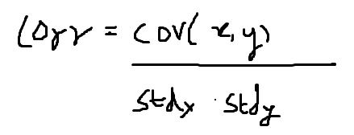where stdx =standard deviation of x and stdy= standard deviation of y

The denominator being a unit vector product identifies the magnitude of growth between two variables. Numerator being the substantiate movement either in same or different direction. So the relation of two variables moving together out of total growth can be called as correlation.

Alternately, correlation can also be expressed as:

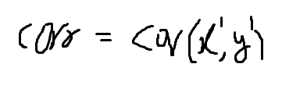where the variables surrounded in covariance are gaussian normalized with G(0,1)

Plugging the above correlation in the total resultant variance:

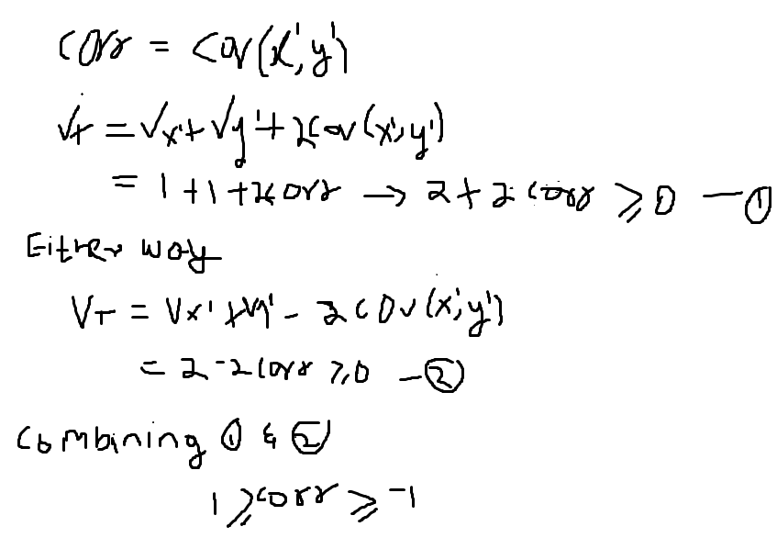

It does not state that correlation stays in the region of [-1,1] only when the variables are gaussian normalized. It happens to everywhere and the below shows the correlation getting normalized:

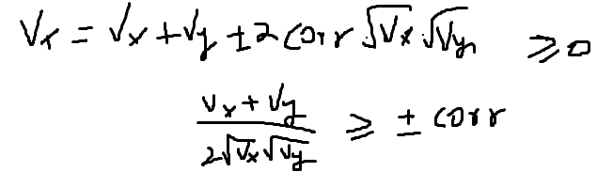The denominator plays key role to make correlation stay in the [-1,1]

Now I consider variance of variable x greater than variance of variable y. From here I take it further:

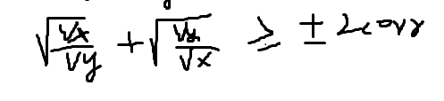

Now we can make substitutions to make this look cleaner

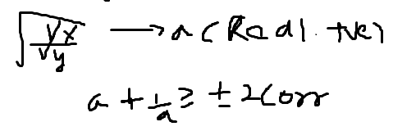

As I assumed to have variance x greater than variance y, I always intend to get a>1/a

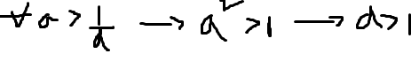is a mathematical expressions of a>1/a. So, on further steps I do a logic:

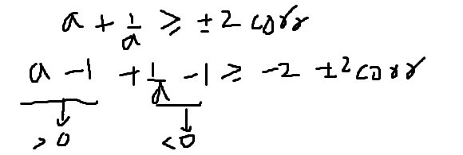

So, you bring to a state where one goes greater than and other goes less than 0. Irrespective the RHS always stays as below:

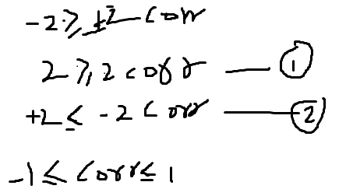So, this should be an alternate approach of proving the correlation domain.